**英语作业**

学校:___________姓名：___________班级：___________考号：___________

**一、单项选择**

1．The man was sad because his life was full ________ sad things. He had to cheer himself up.

A．with B．of C．to D．for

2．—Alice plays ________ chess well.

—She wants to join the chess club next week.

A．a B．an C．the D．/

3．There is something wrong with my car. May I use ________?

A．you B．your C．yours D．yourself

4．It’s not easy for us _________ a new way to stop procrastination (拖延症)．

A．find B．finding C．found D．to find

5．I plan to ________ hip hop dancing as my new hobby this term.

A．take away B．take off C．take out D．take up

6．I’m interested in animals, so I ________ every Saturday working in an animal hospital.

A．pay B．cost C．take D．spend

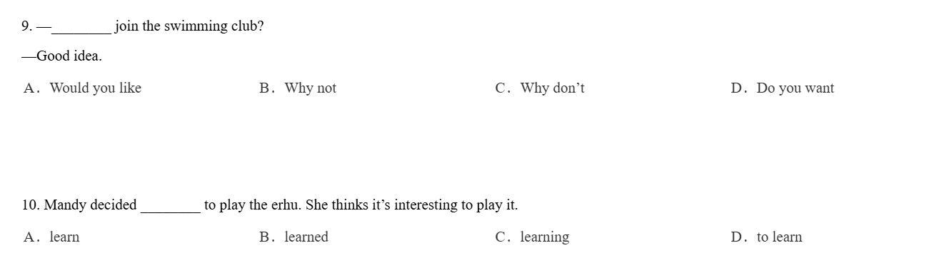

**二、完成句子**

7．The volunteers often go to the nursing home to take care of the old. （保持原义不变）

The volunteers often go to the nursing home to the old.

8．I don’t know how I can reach the hospital.（保持原意不变）

I don’t know how I can the hospital.

**三、单词拼写**

9．He wants to be an when he grows up. (act)

**四、短文填空**

读短文，用恰当的词填空。首字母已给。

1. The taxi driver

My job is to pick people up from my place and take them to another place safely and efficiently. I drive my car around town and try to provide a good experience for everyone, it’s all about driving, helping others and making sure everyone a 10 at the destination happily and satisfiedly.

2.The paramedic (护理人员)

In my job, one of the most important things is to stay c 11 because sometimes it’s a matter of life and death when emergency (紧急情况) happens, we need to get the p 12 to the hospital as quickly as possible, it’s important to be decisive. To be able to make the right decision at the right time.

3.The architect

My job is both an indoor and an outdoor one, I spent quite a lot of time in the office, working on plans for bridges and b 13 and so on, but I also spent a lot of time on site working and discussing with the builders.

4. The waiter

My job is quite t 14 , I am on my feet all day, you have to be polite too. Most customers are really nice, but there are one or two who are just so difficult to please, they would say this is too salty or this is too spicy. And want to return the dishes, but you have to remember: the customer is always right.

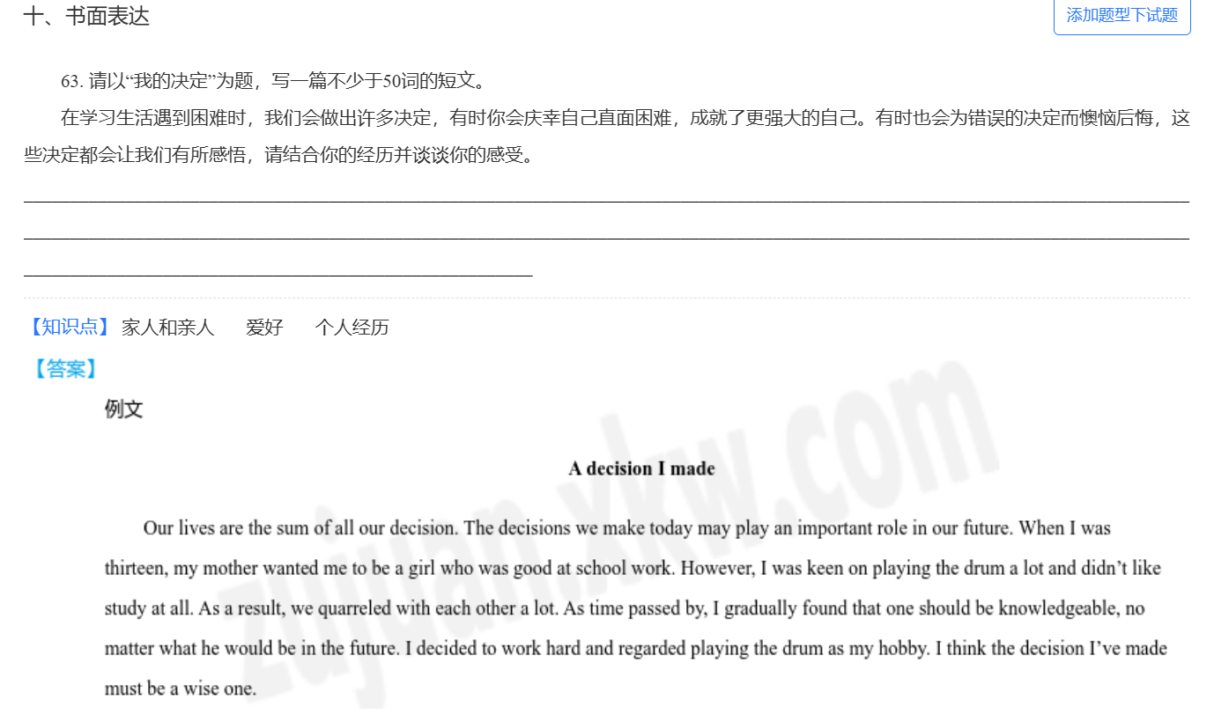

**参考答案：**

|  |  |  |  |  |  |  |  |  |  |  |
| --- | --- | --- | --- | --- | --- | --- | --- | --- | --- | --- |
| **题号** | 1 | 2 | 3 | 4 | 5 | 6 |  |  |  |  |
| **答案** | B | D | C | D | D | D |  |  |  |  |

1．B

2．D

3．C

4．D

5．D

6．D

7． look after

8． get to

9．actor

10．(a)rrives 11．(c)alm 12．(p)atients 13．(b)uildings 14．(t)iring 15．(p)lease